'Programmer: Samantha Naini
'Date: 4/12/2012
'Exercise: Ch 6 exam (6-1-36)
'Program purpose: Calculating a savings plan annuity with 3% interest compounded per month.

Option Strict On
Option Explicit On

Public Class frmCh6Exam

Private Sub btnCompute_Click(ByVal sender As System.Object, ByVal e As System.EventArgs) Handles btnCompute.Click

Dim Deposit, numOfMonths, intRate As Double

If txtDeposit.Text = Nothing And txtIntRate.Text = Nothing Then
MessageBox.Show("Monthly deposit and/or interest rate is not valid. please re-enter data.", "6-1-36")
Else
If IsNumeric(txtDeposit.Text) And IsNumeric(txtIntRate.Text) Then

Deposit = CDbl(txtDeposit.Text)
intRate = CDbl(txtIntRate.Text)

Do Until Deposit > 3000

Deposit = 1.0025 * Deposit + 100
numOfMonths += 1
Loop

txtAcctBal.Text = FormatCurrency("" & Deposit & "")
txtNumOfMonths.Text = ("" & numOfMonths & "")
End If
End If

End Sub

Private Sub btnClear_Click(ByVal sender As System.Object, ByVal e As System.EventArgs) Handles btnClear.Click
txtDeposit.Clear()
txtDeposit.Focus()
txtIntRate.Clear()
txtNumOfMonths.Clear()
txtAcctBal.Clear()
End Sub

Private Sub btnEnd_Click(ByVal sender As System.Object, ByVal e As System.EventArgs) Handles btnEnd.Click

If MsgBox("Do you really want to quit?", MsgBoxStyle.YesNoCancel, "End Program") = MsgBoxResult.Yes Then
MsgBox("have a nice day!")
Me.Close()
End If

End Sub

End Class
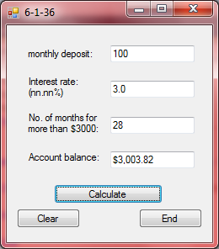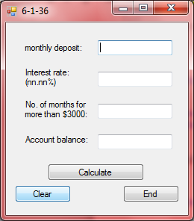←Clear button
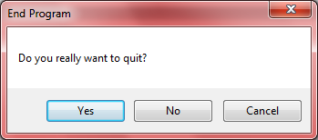 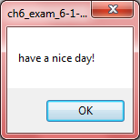⬅End button
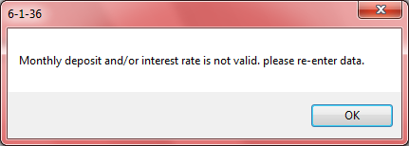←if no data is entered

